1. **When trying to achieve linearity between energy usage and compute usage there is a need to feedback some of the compute needs to energy control plane. Suggest some techniques to apply such feedback (Hint: Slide8). Explain your answer in GREAT details.**

These techniques include:

1. Using software to operate hardware when needed

That means auto-control of remote in energy management. We can think the stream line of industrial evolution as a machine automatic, but driving these equipment must consume an amount of energy. So during the era of computer and internet, it has maturity condition to reduce these consumptions because of the created “High-Way”. We can turn on or off Ups, switch on plug and monitor temperature and moisture, etc. In software layer, we only focus on the static equipment to use power and do its best to implement action for all equipment through software operation.

1. Semantic-less Coordination of Power Management and Application Performance

Joint system and application optimization would thus be more appropriate and has been considered. While the joint methods offer improved and potentially optimal power-performance management, they require communicating semantic information about the behaviors of multiple modules across the system-application boundary. This semantic information is generally hard to obtain and use. For example, an application may be required to run on many different types of servers with varying power management capabilities. It would then be necessary to design the application to recognize the different semantics used by system modules on each server type. Moreover, physical systems may be shared by multiple applications, as is the case for a cloud computing infrastructure or for software from multiple vendors on a single laptop, implying that no single entity can control all knobs.

1. HDD vs SSD

A solid state drive or SSD can speed up the performance of a computer significantly, often more than what a faster processor (CPU) can. This is obviously equivalent to decrease the energy usage.

A hard disk drive or HDD is cheaper and offers more storage (500 GB to 1 TB are common) while SSD disks are more expensive and generally available in 64 GB to 256 GB configurations.

1. Using “sleep” mode in server/rack

Sleep mode is a low power mode for electronic devices such as computers, televisions, and remote controlled devices. These modes save significantly on electrical consumption compared to leaving a device fully on and, upon resume, allow the user to avoid having to reissue instructions or to wait for a machine to [reboot](https://en.wikipedia.org/wiki/Booting). Many devices signify this power mode with a pulsed or red colored [LED](https://en.wikipedia.org/wiki/LED) power light. Using it might effectively reduce energy consumption than normal open server because commonly it always has many servers not to provide service in datacenter.

1. **We discussed the need to measure IT equipment energy consumption. Explain why it is important? How we can measure such energy consumption? (Hint: Slide6). Explain your answer in GREAT details.**
2. Important Reason:

Power Showing: Measuring IT equipment energy consumption helps us learn the distribution of power in datacenter and grasp which part cost how many power energy;

Improving the Energy Efficiency: The PUE value represents overhead which has huge impact for running of system. High PUE values might indicates on high overhead. These values make us to improve the Energy Efficiency by analyzing.

1. Calculated Value:

PUE = Total Facility Power / IT Equipment Power

How to measure generally use two pattern: WSC and HPC

1. WSC: For comparing the relative efficiency of two WSCs or to guide the design choices for new systems. Unfortunately, no two companies run the same workload and real-world application mixes change all the time, so it is hard to benchmark using real-world data if the objective is to compare two WSCs.

The measuring step is define workload scence, create baseline like ops/sec and measure to compare.

1. HPC: In the high-performance computing (HPC) area, there is a recent attempt to begin ranking the energy efficiency world’s top supercomputers using existing HPC benchmarks (LINPACK) called the Green 500. We are not aware of a similar initiative for Internet services.

Benchmarks such as SPECpower_ssj2008 provide a standard application base that is representative of a broad class of server workloads, and it can help us isolate efficiency differences in the hardware platform.

1. **Name three takeaways from week 7 lecture.**
2. Learning PUE details: it lets me to know how to improving the power efficiency. More importantly, through the processing of calculating this value, I understand the relationship between IT Equipment Power and other Facility Power.
3. Measuring the Efficiency of Computing: If we want to obtain it, we must define the workload depending on the actual situation. In different workload like Read Heavy or Update Heavy, it will occur different performance in Power Consumption. In the meantime, using different software maybe display different value totally. I feel measuring is a complicated task for datacenter.
4. Proportional Computing: When a datacenter has created, its energy consumption might be happened various up and down even not enough to provide the system. So as a designer, we have to measure these values about power timely. I learned several critical skills to solve this problem from the class such as using software of monitor, Coordination, comparing hardware strategy and how to apply sleep mode. This point is important to keep the stability of datacenter.
5. In class we conducted a benchmark using live_socket_srv.c and socket.c. The benchmark collected information about the number of open descriptors. Conduct the benchmark on your VM and share the results of your max server capacity.

(1) Run server function live_socket_srv in ec2-54-200-216-172.us-west-2.compute.amazonaws.com and IP is 54.200.216.172

(2) Run client function socket in ec2-54-200-5-84.us-west-2.compute.amazonaws.com and IP is 54.200.5.84

(3)In my server machine, the status is :

ubuntu@ip-172-31-40-191:~$ ps -aux |grep live

ubuntu 6640 0.0 0.0 4192 356 pts/0 S+ 03:56 0:00 ./live_socket_srv.o

ubuntu 6654 0.0 0.0 10460 936 pts/1 S+ 03:59 0:00 grep --color=auto live

ubuntu@ip-172-31-40-191:~$ sudo lsof|grep 6640 |wc -l

9

ubuntu@ip-172-31-40-191:~$ sudo netstat -anp | grep 6640 |wc -l

1

When I execute socket once in my client machine, like this :

ubuntu@ip-172-31-42-190:~/UnixSysProgramming$ ./socket.sh

Resolving the hostname ec2-54-200-216-172.us-west-2.compute.amazonaws.com

ec2-54-200-216-172.us-west-2.compute.amazonaws.com resolved to : 172.31.40.191

Connecting to hostname ec2-54-200-216-172.us-west-2.compute.amazonaws.com on IP 172.31.40.191

Connecting to port 8023

Connected

Data Sent

Reply received

Hello Client , I have received your connection. But I have to go now, bye

Then the processing of server will add 1, this is :

ubuntu@ip-172-31-40-191:~$ sudo lsof|grep 6640 |wc -l

10

ubuntu@ip-172-31-40-191:~$ sudo netstat -anp | grep 6640 |wc -l

2

When I loop the socket and the max situation in server machine is:

ubuntu@ip-172-31-42-190:~/UnixSysProgramming$ ./socket.sh

ubuntu@ip-172-31-40-191:~$ sudo lsof|grep 6640 |wc -l

1029

ubuntu@ip-172-31-40-191:~$ sudo netstat -anp | grep 6640 |wc -l

1021

ubuntu@ip-172-31-40-191:~$ sudo ps aux | grep 6640 | awk '{ print $4,$5 }'

0.0 4192

0.0 10460

1. Tomcat install:

https://www.digitalocean.com/community/tutorials/how-to-install-apache-tomcat-7-on-ubuntu-14-04-via-apt-get

ubuntu@ip-172-31-42-190:~/UnixSysProgramming$ sudo groupadd tomcat

ubuntu@ip-172-31-42-190:~/UnixSysProgramming$ sudo useradd -s /bin/false -g tomcat -d /opt/tomcat tomcat

ubuntu@ip-172-31-42-190:~$ sudo vi /etc/default/tomcat7

ubuntu@ip-172-31-42-190:~$ sudo service tomcat7 restart

* Stopping Tomcat servlet engine tomcat7 [ OK ]

* Starting Tomcat servlet engine tomcat7 [ OK ]

ubuntu@ip-172-31-42-190:~$ ps -ef | grep -i tomcat

tomcat7 18897 1 19 03:14 ? 00:00:03 /usr/lib/jvm/default-java/bin/java -Djava.util.logging.config.file=/var/lib/tomcat7/conf/logging.properties -Djava.util.logging.manager=org.apache.juli.ClassLoaderLogManager -Djava.security.egd=file:/dev/./urandom -Djava.awt.headless=true -Xmx512m -XX:MaxPermSize=256m -XX:+UseConcMarkSweepGC -Djava.endorsed.dirs=/usr/share/tomcat7/endorsed -classpath /usr/share/tomcat7/bin/bootstrap.jar:/usr/share/tomcat7/bin/tomcat-juli.jar -Dcatalina.base=/var/lib/tomcat7 -Dcatalina.home=/usr/share/tomcat7 -Djava.io.tmpdir=/tmp/tomcat7-tomcat7-tmp org.apache.catalina.startup.Bootstrap start

ubuntu 18919 2899 0 03:15 pts/0 00:00:00 grep --color=auto -i tomcat

ubuntu@ip-172-31-42-190:~$ netstat -an|grep -i 8080

tcp6 0 0 :::8080 :::* LISTEN

<http://ec2-54-200-5-84.us-west-2.compute.amazonaws.com:8080/>

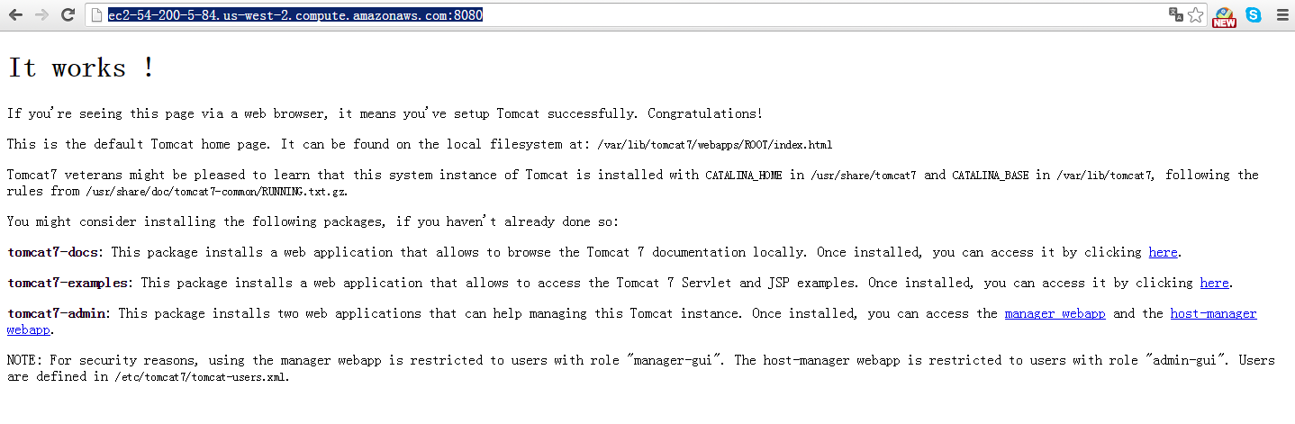

<http://ec2-54-200-5-84.us-west-2.compute.amazonaws.com:8080/host-manager/html>

